Lab Practical #8:

Study & Survey of Institute organization network infrastructure.

# Practical Assignment #8:

## 1.Identify type of network in your institute. Draw a design of network in your institute (Any Lab/Floor/Building).

### Type of Network in Institute:

The institute’s internal network is a **Local Area Network (LAN)**, which connects different labs, classrooms, and administrative offices within the campus.

**Topology Used: Star Topology**

* In this topology, all devices (computers, printers, etc.) are connected to a central networking device such as a **switch**.
* The switch acts as the hub that manages and forwards data to the correct device.

**Lab No: C- 302**

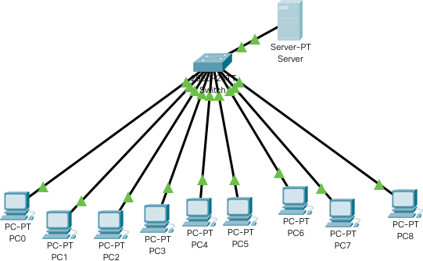**Topology:** Star Topology

## 2.List how many network devices and types of cable used and give its details.

### Network Devices:

#### Router

* Connects the institute’s LAN to the Internet Service Provider (ISP).
* Responsible for forwarding packets between different networks.

#### Switch

* A central device to which multiple computers in the lab are connected.
* Provides efficient communication within the local network.

#### Firewall

* Ensures secure communication by filtering unwanted traffic and preventing unauthorized access.

#### Wireless Access Point (AP)

* Extends network connectivity wirelessly so laptops and mobile devices can join the LAN.

#### Network Interface Card (NIC)

* Every computer system has a NIC installed (either integrated or separate) that allows it to connect to the network.

#### Modem

* Converts digital signals from the router into signals that can travel over the ISP’s medium (fiber/DSL).

#### Load Balancer

* Distributes internet and network traffic efficiently across multiple servers, improving performance and reducing downtime.

### Types of Cables:

#### Ethernet Cable (Twisted Pair - Cat5e, Cat6, Cat6a)

* Used for wired connections between PCs, switches, and routers.
* Supports high data transfer speeds (up to 1–10 Gbps depending on category).

#### Fiber Optic Cable

* Used for backbone connections across different buildings/floors.
* Provides very high-speed data transfer with minimal loss.

#### Coaxial Cable

* Less commonly used now, but may exist in older parts of the network.
* Provides a shielded medium for carrying electrical signals.

#### Console Cable (RJ45 to Serial/USB)

* Used by administrators for configuring routers and switches directly through a computer terminal.